**IBM REPORT**

**TEAM ID : PNT2022TMID20053**

**Project Name : Personal Expense Tracker**

**Team Members:**

**Prasanna Kumar A -49621912019**

**Joshua Isaac Raj J -  49621912011**

**Ramkumar M - 49621912023**

**Ram Praveen S - 49621912037**

**1. INTRODUCTION**

***1.1 Project Overview***

In simple words, personal finance entails all the financial decisions and activities that a Finance app makes your life easier by helping you to manage your finances efficiently. A personal finance app will not only help you with budgeting and accounting but also give you helpful insights about money management.

Personal finance applications will ask users to add their expenses and based on their expenses wallet balance will be updated which will be visible to the user.  Also, users can get an analysis of their expenditure in graphical forms. They have an option to set a limit for the amount to be used for that particular month if the limit is exceeded the user will be notified with an email alert.

***1.2 Purpose***

This application is used to track the user's expenses and alert the user if he/she exceeds his/her budget limit. By alerting the user, they can limit their expenses to make it within the budget limit. So that the user will not exceed the budget limit and can save money from unwanted expenses.

**2.LITERATURE SURVEY**

***2.1 Existing Problem***

It takes long time

Need to check Frequently

***2.2 Refernces***

* + 1. Y. Anita, R. Ranjini, S. Gomathi, “Easy App for Expanses Manager Using Android”, International Journals of Computer Techniques, Volume: 3 Issue: 2,ISSN: 2394-2231(MarchApril 2016).
    2. N. ZahiraJahan MCA., M. Phil, K. I. Vinodhini, “Personalized Expense Managing Assistant Using Android”, International Journals of ComputerTechniques (IJCT), Volume:3 Issue: 2, ISSN: 2394-2231 (March-April 2016).
    3. S.Chandini, T. Poojitha,D. Ranjith, V. J. MohammedAkram, M. S. Vani, V.Rajyalakshmi, “Online Income and Expense Tracker”, International Research Journal of Engineering and Technology (IRJET), Volume: 06 Issue: 3, e-ISSN:2395-0056, p- ISSN: 2395- 0072 (March 2019).
    4. P.Thanapal, Mohammed Yaseen Patel, T. P. Lokesh Raj and J. SatheeshKumar, “Income and Expense Tracker”, Indian Journal of Science andTechnology, Vol 8(S2), ISSN: 0974-5645 (January 2014).
    5. Girish Bekaroo and Sameer Sunhaloo, “Intelligent Online BudgetTracker”, ComputerScience and IT Education Conference (2014).

***2.3 Problem Statement Definition***

The Customer Problem Statement template helps you focus on what matters to create experiences people will love. A well-articulated customer problem statement allows you and your team to find the ideal solution for the challenges your customers face. Throughout the process, you’ll also be able to empathize with your customers, which helps you better understand how they perceive your product or service.

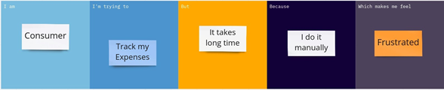

**3. IDEATION & PROPOSED SOLUTION**

***3.1 Empathy Map Canvas***

***3.2 Ideation & Brainstorming***

Brainstorming provides a free and open environment that encourages everyone within a team to participate in the creative thinking process that leads to problem solving. Prioritizing volume over value, out-of-the-box ideas are welcome and built upon, and all participants are encouraged to collaborate, helping each other develop a rich amount of creative solutions.

Step-1: Team Gathering, Collaboration and Select the Problem Statement

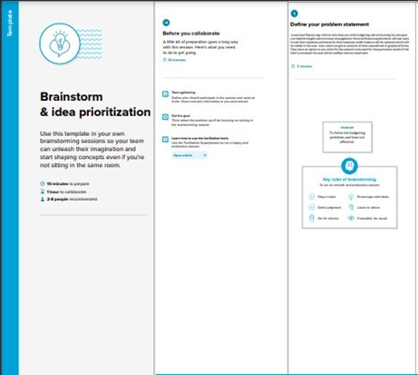

Step-2: Brainstorm, Idea Listing and Grouping

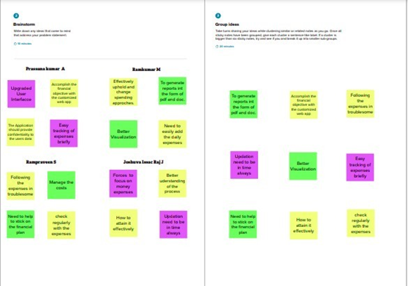

Step-3: Idea Prioritization

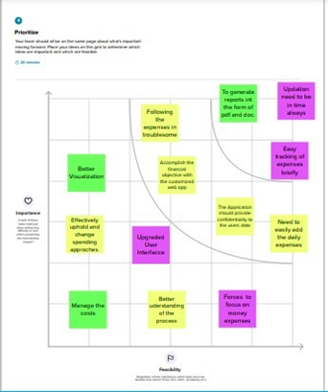

***3.3 Proposed Solution***

|  |  |  |
| --- | --- | --- |
| S.No. | Parameter | Description |
| 1. | Problem Statement (Problem to be solved) | Many people facing problems in budgeting their monthly expenses due to lack of knowledge in budgeting and they lose their money in unwanted expenditure. It is difficult for them to manage their expense manually using some traditional methods like notebooks/diaries. So they need a better software application which can manage their expenses and make them alert when they exceed their budget limit. It should provide better budgeting ideas for them to improve their budgeting knowledge and to reduce  unwanted expenditure. |
| 2. | Idea / Solution description | To create personal expense tracker application which manage their income and expenditure details and gives better ideas to the user to reduce unnecessary expense and budgeting ideas. It will alert the user when he/she exceeds the budget limit.User can analysehis  expense details and make a reportof it. |
| 3. | Novelty / Uniqueness | This personal expense tracker Application has features that enables the user to have an option to set a limit for the amount to be used. If the limit is exceeded the user will be notified with an Emailand SMS alert.  It has bot that can understand and answer all user queriesand address their needs. |
| 4. | Social Impact/ Customer Satisfaction | User can track their income and expense details.  It notifies the user when budget limit is exceeded so that user can be aware in spending  money. |
| 5. | Business Model(Revenue Model) | This application can be made with free and premium access. If a user needs a ad-free environment they should have a premium subscription. So through this advertisement freesubscription-based revenue model will  earn money which can be useful for the maintenance of the application. |
| 6. | Scalability of the Solution | This application has a better storage capacity to maintain large amount of data.  This project is highly feasible and can update our income, expense and budget details wheneverthe user needs to change.  Since this application is deployed on IBM Cloud,  it can handle multiple usersat a time |

***3.4 Problem Solution fit***

The Problem-Solution Fit simply means that you have found a problem with your customer and that the solution you have realized for it actually solves the customer’s problem. It helps entrepreneurs, marketers and corporate innovators identify behavioral patterns and recognize what would work and why

**Purpose:**

* Solve complex problems in a way that fits the state of your customers.
* Succeed faster and increase your solution adoption by tapping into existing mediums and channels of behavior.
* Sharpen your communication and marketing strategy with the right triggers and messaging.
* Increase touch-points with your company by finding the right problem-behavior fit and building trust by solving frequent annoyances, or urgent or costly problems.
* Understand the existing situation in order to improve it for your target group.

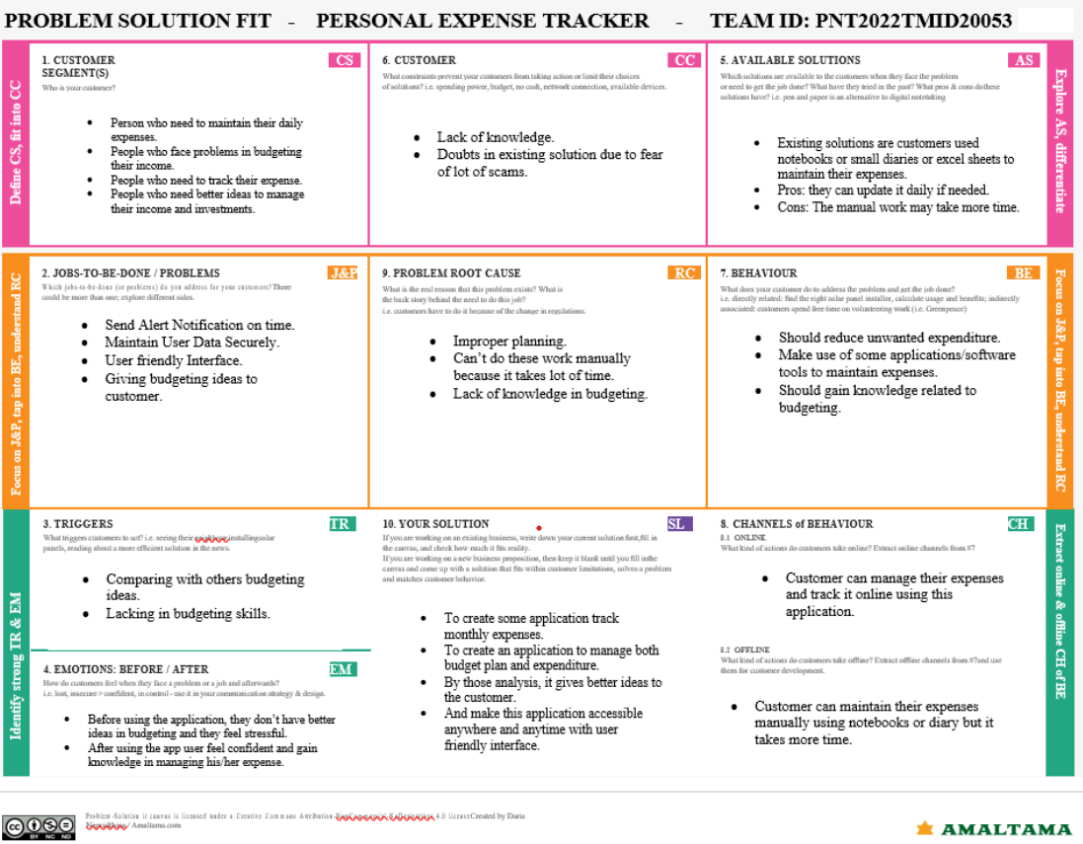

**4. REQUIREMENT ANALYSIS**

***4.1 Functional requirement***

|  |  |  |
| --- | --- | --- |
| **FR No.** | **Functional Requirement (Epic)** | **Sub Requirement (Story / Sub-Task)** |
| FR-1 | User Registration | Registration through Phone number  Registration through Gmail |
| FR-2 | User Confirmation | Confirmation via Email  Confirmation via OTP |
| FR-3 | User Login | Login using Gmail |
| FR-4 | Manage Expenses | Create or update newbudget/expense limit. |
| FR-5 | Expense Tracker | Analyse the level of expenses in graphical report format |
| FR-6 | Manage incomeand expenditure | Create or update incomeand expenditure details, then  the app suggests betterideas for budgeting. |

***4.2 Non-Functional requirements***

|  |  |  |
| --- | --- | --- |
| **FR No.** | **Non-Functional Requirement** | **Description** |
| NFR-1 | **Usability** | This system will be used by anyone who needs to  manage their expenses and to make better budgeting ideas. |
| NFR-2 | **Security** | This system prevents customer’s data securely and protects from malware attacks or unauthorized  access. |
| NFR-3 | **Reliability** | This system is highly reliable and it reduces the  manual work load. |
| NFR-4 | **Performance** | It tracks the expenses and generates reports quickly. It engages usersefficiently with betterbudgeting  ideas. |
| NFR-5 | **Availability** | User can make his/her reports offline and thisreport  is operational at any time. |
| NFR-6 | **Scalability** | This system has betterstorage capacity and it  manages large no ofuser’s data. |

**5. PROJECT DESIGN**

***5.1 Data Flow Diagrams***

A Data Flow Diagram (DFD) is a traditional visual representation of the information flows within a system. A neat and clear DFD can depict the right amount of the system requirement graphically. It shows how data enters and leaves the system, what changes the information, and where data is stored.

***5.2 Solution & Technical Architecture***

Personal finance applications will ask users to add their expenses and based on their expenses wallet balance will be updated which will be visible to the user.  Also, users can get an analysis of their expenditure in graphical forms. They have an option to set a limit for the amount to be used for that particular month if the limit is exceeded the user will be notified with an email alert.

**Components & Technologies:**

|  |  |  |  |
| --- | --- | --- | --- |
| **S.No** | **Component** | **Description** | **Technology** |
| 1. | User Interface | How user interacts with application e.g. WebUI, Mobile App, Chatbotetc. | HTML, CSS,JavaScript etc. |
| 2. | Application Logic-1 | The application contains the sign in/sign up page where the user will logininto the maindashboard | Python |
| 3. | Application Logic-2 | Dashboard contains the fields like add expenses , addbudget limit. | IBM WatsonSTT service |
| 4. | Application Logic-3 | The user will receive alert notification if budget limits exceeds and gets the expense and income analysis report with better ideas. | IBM WatsonAssistant |
| 5. | Database | The database contains expenses, budget limit informations. | MySQL |
| 6. | Cloud Database | User information are stored securely in cloud database. | IBM DB2 |
| 7. | File Storage | The user’s income and finance data are stored in ibm block storage. | IBM Block Storage or LocalFilesystem |
| 8. | External API-1 | Purpose of External API used in the application | SendGrid API |
| 9. | External API-2 | Purpose of External API used in the application | Economic News API |
| 10. | Container Registry | Container images storage | Local Registry: DockerHub  Cloud Registry: Container Registry |
| 11. | Infrastructure (Server / Cloud) | Application Deployment on Local System / Cloud Local Server Configuration: Minikube  Cloud Server Configuration : Kubernetes | Local, CloudFoundry, Kubernetes, etc. |

**Application Characteristics:**

|  |  |  |  |
| --- | --- | --- | --- |
| **S.No** | **Characteristics** | **Description** | **Technology** |
| 1. | Open-Source Frameworks | Flask framework in python is used to implement this application | Python - Flask |
| 2. | Security Implementations | This application provides high security to the user  financial data. It can be done using the container registry in IBM cloud | Container Registry, Kubernetes |
| 3. | Scalable Architecture | This application has lifetime access.  Large amount of data can be stored in cloud database. | Container Registry, Kubernetes |
| 4. | Availability | This application can accessible by for any number of users and it is available at anytime. | Container Registry, Kubernetes cluster |
| 5. | Performance | The Performance of this application is high because there will be no network traffic. | Kubernetes cluster |

***5.3 User Stories***

|  |  |  |  |  |  |  |
| --- | --- | --- | --- | --- | --- | --- |
| **User Type** | **Functional**  **Requirement**  **(Epic)** | **User Story Number** | **User Story/ Task** | **Acceptance**  **criteria** | **Priority** | **Release** |
| Customer (Mobile user) | Registration | USN-1 | As a user,I can register for the application by entering my email, password, and confirming my password. | I can accessmy account / dashboard | High | Sprint-1 |
|  |  | USN-2 | As a user, I will receive confirmation email once I haveregistered for the application | I can receive confirmation email &click confirm | Medium | Sprint-1 |
|  |  | USN-3 | As a user, I can register for the application through Facebook | I can register &access the dashboard with Facebook  Login | Low | Sprint-2 |
|  |  | USN-4 | As a user, I can register for the application through phone number and OTP | I can register my mobile number | High | Sprint-1 |
|  | Login | USN-5 | As a user, I can log into the application by entering email & password | I can log into the application withemail | High | Sprint-1 |
|  | Dashboard | USN-6 | As a user,I can Add or updatemy budget limit | I can manage budget limit | High | Sprint-1 |
| Customer (Web user) | Registration | USN-7 | As a user, I can register using google gmail account. | I can update/ track my expenditure details | Medium | Sprint-1 |
| Customer Care Executive | Chat Bot | USN-8 | As a customer care officer, I can solve the  problems facedby the user and address the solution for their queries | Customer care service in available at any time. | High | Sprint-1 |
| Administrator | Login | USN-9 | As an Administrator, I can login through my username and password | I can login through my username and password | High | Sprint-1 |
|  | Dashboard | USN-10 | As a Administrator, I can ableto view theuser’s basic information | I can view userinfo | Medium | Sprint-1 |
|  | Dashboard | USN-11 | As a administrator, I can ableto view overall progress of user | I can giverewards based on their progress | Low | Sprint-1 |
|  | Application updation | USN-12 | As a administrator, I can updatethe application | I can fix any bugs raised  by customer and upgradethe application | High | Sprint-4 |

**6. PROJECT PLANNING & SCHEDULING**

***6.1 Sprint Planning & Estimation***

|  |  |  |  |  |  |  |
| --- | --- | --- | --- | --- | --- | --- |
| **Sprint** | **Functional**  **Requirement (Epic)** | **User Story Number** | **User Story/ Task** | **Story Points** | **Priority** | **Release** |
| Sprint 1 | Registration | USN-1 | As a user, I can register for the application by  entering my email, password, and confirming my password. | 2 | High | Prasanna Kumar |
| Sprint 1 |  | USN-2 | As a user, I will receive confirmation email  once I have registered for the application | 1 | Medium | Joshua IsaacRaj |
| Sprint 2 |  | USN-3 | As a user, I can register for the application through Facebook | 2 | Low | Ram Kumar |
| Sprint 1 |  | USN-4 | As a user, I can register for the application  through phone numberand OTP | 2 | High | Ram Praveen |
| Sprint 1 | Login | USN-5 | As a user, I can loginto the application by  entering email &password | 1 | High | Prasanna Kumar |
|  | Dashboard | USN-6 | As a user, I can Add or update my budgetlimit | 2 | High | Joshua IsaacRaj |
|  | Registration | USN-7 | As a user, I can register using google gmail  account. | 2 | Medium | Ram Kumar |
| Sprint 2 | Chat Bot(Customer Care Executive) | USN-8 | As a customer care officer, I can solvethe  problems faced by the user andaddress the solution for their queries | 1 | High | Ram Praveen |
| Sprint 3 | Login(admin) | USN-9 | As an Administrator, I can loginthrough my  username and password | 2 | High | Prasanna Kumar |
|  | Dashboard(admin) | USN-10 | As a Administrator, I can able to view the  user’s basic information | 1 | Medium | Joshua IssacRaj |
|  | Dashboard(admin) | USN-11 | As a administrator, I can ableto view overall  progress of user | 2 | Low | Ram Kumar |
|  | Application updation | USN-12 | As a administrator, I can update the application | 2 | High | Ram Praveen |

***6.2 Sprint Delivery Schedule***

|  |  |  |
| --- | --- | --- |
| **TITLE** | **DESCRIPTION** | **DATE** |
| **Literature Survey & Information Gathering** | conducting a literature review on the chosen projectand gathering data by consulting technical papers, research publications, etc. | 3rd SEPTEMBER 2022 |
| **Prepare EmpathyMap** | Get an Empathy Map Canvas ready to record the user's gains and pains. Make a list of the problems. | 10th SEPTEMBER 2022 |
| **Ideation** | List the ideasgenerated during the brainstorming session and rank the top threeaccording to importance and viability. | 17thSEPTEMBER 2022 |
| **Proposed Solution** | Create a proposal for a solution that details its novelty, viability as a business idea, social impact, scalability,and otherfactors. | 24thSEPTEMBER 2022 |
| **Problem Solution Fit** | Get a problem-solution-fit document ready. | 1st OCTOBER 2022 |

|  |  |  |
| --- | --- | --- |
| **Solution Architecture** | Prepare solution architecture document. | 1st OCTOBER 2022 |
| **Customer Journey** | Create customer journey maps to comprehend how users interact with and use the application (entryto exit). | 8thOCTOBER 2022 |
| **Functional Requirement** | Prepare         the        functional requirement document. | 14th OCTOBER 2022 |
| **Data FlowDiagrams** | Make the data flow diagrams, then submitthem for evaluation. | 15th OCTOBER 2022 |
| **Sprint Delivery Plan** | Allocate time for each and every phaseof the project | 21nd OCTOBER 2022 |
| **Prepare Milestone & ActivityList** | Create a list of the project's milestones and activities. | 22ndOCTOBER 2022 |
| **Project Development - Delivery of Sprint-1, 2, 3 &**  **4** | Develop      &      submit       the developed code by testingit. | IN PROGRESS(will be completed within19th Nov) |

.

***6.3 Reports from JIRA***

**7.Coding & Solutioning**

***7.1 Feature1***

**Login.html:**

**<link href="https://stackpath.bootstrapcdn.com/bootstrap/4.3.1/css/bootstrap.min.css" rel="stylesheet">**

**<link href="https://cdnjs.cloudflare.com/ajax/libs/font-awesome/4.7.0/css/font-awesome.min.css" rel="stylesheet">**

**<script src="https://stackpath.bootstrapcdn.com/bootstrap/4.3.1/js/bootstrap.bundle.min.js"></script>**

**<script src="https://cdnjs.cloudflare.com/ajax/libs/jquery/3.2.1/jquery.min.js"></script>**

**<style>**

**body {**

**color: #000;**

**overflow-x: hidden;**

**height: 100%;**

**background-color: #B0BEC5;**

**background-repeat: no-repeat;**

**}**

**.card0 {**

**box-shadow: 0px 4px 8px 0px #757575;**

**border-radius: 0px;**

**}**

**.card2 {**

**margin: 0px 40px;**

**}**

**.logo {**

**width: 200px;**

**height: 100px;**

**margin-top: 20px;**

**margin-left: 35px;**

**}**

**.image {**

**width: 360px;**

**height: 280px;**

**}**

**.border-line {**

**border-right: 1px solid #EEEEEE;**

**}**

**.facebook {**

**background-color: #3b5998;**

**color: #fff;**

**font-size: 18px;**

**padding-top: 5px;**

**border-radius: 50%;**

**width: 35px;**

**height: 35px;**

**cursor: pointer;**

**}**

**.twitter {**

**background-color: #1DA1F2;**

**color: #fff;**

**font-size: 18px;**

**padding-top: 5px;**

**border-radius: 50%;**

**width: 35px;**

**height: 35px;**

**cursor: pointer;**

**}**

**.linkedin {**

**background-color: #2867B2;**

**color: #fff;**

**font-size: 18px;**

**padding-top: 5px;**

**border-radius: 50%;**

**width: 35px;**

**height: 35px;**

**cursor: pointer;**

**}**

**.line {**

**height: 1px;**

**width: 45%;**

**background-color: #E0E0E0;**

**margin-top: 10px;**

**}**

**.or {**

**width: 10%;**

**font-weight: bold;**

**}**

**.text-sm {**

**font-size: 14px !important;**

**}**

**::placeholder {**

**color: #BDBDBD;**

**opacity: 1;**

**font-weight: 300**

**}**

**:-ms-input-placeholder {**

**color: #BDBDBD;**

**font-weight: 300**

**}**

**::-ms-input-placeholder {**

**color: #BDBDBD;**

**font-weight: 300**

**}**

**input, textarea {**

**padding: 10px 12px 10px 12px;**

**border: 1px solid lightgrey;**

**border-radius: 2px;**

**margin-bottom: 5px;**

**margin-top: 2px;**

**width: 100%;**

**box-sizing: border-box;**

**color: #2C3E50;**

**font-size: 14px;**

**letter-spacing: 1px;**

**}**

**input:focus, textarea:focus {**

**-moz-box-shadow: none !important;**

**-webkit-box-shadow: none !important;**

**box-shadow: none !important;**

**border: 1px solid #304FFE;**

**outline-width: 0;**

**}**

**button:focus {**

**-moz-box-shadow: none !important;**

**-webkit-box-shadow: none !important;**

**box-shadow: none !important;**

**outline-width: 0;**

**}**

**a {**

**color: inherit;**

**cursor: pointer;**

**}**

**.btn-blue {**

**background-color: #1A237E;**

**width: 150px;**

**color: #fff;**

**border-radius: 2px;**

**}**

**.btn-blue:hover {**

**background-color: #000;**

**cursor: pointer;**

**}**

**.bg-blue {**

**color: #fff;**

**background-color: #1A237E;**

**}**

**@media screen and (max-width: 991px) {**

**.logo {**

**margin-left: 0px;**

**}**

**.image {**

**width: 300px;**

**height: 220px;**

**}**

**.border-line {**

**border-right: none;**

**}**

**.card2 {**

**border-top: 1px solid #EEEEEE !important;**

**margin: 0px 15px;**

**}**

**}**

**</style>**

**<script>**

**window.setTimeout(function () {**

**$(".alert").fadeTo(500, 0).slideUp(500, function () {**

**$(this).remove();**

**});**

**}, 4000);**

**</script>**

**<div class="{% if msg =='error' %}alert alert-warning{% else %}fade {% endif %}">**

**<strong>Warning!</strong> {{session.msg}} <strong>failed.</strong>**

**</div>**

**<div class="{% if msg =='success' %}alert alert-success{% else %}fade{% endif %}" role="alert">**

**<strong>success!</strong> {{session.msg}} <strong>completed.</strong>**

**</div>**

**<div class="container-fluid px-1 px-md-5 px-lg-1 px-xl-5 py-5 mx-auto">**

**<div class="card card0 border-0">**

**<div class="row d-flex">**

**<div class="col-lg-6">**

**<div class="card1 pb-5">**

**<div class="row">**

**</div>**

**<div class="row px-3 justify-content-center mt-4 mb-5 border-line">**

**<img style="margin-top:20%;" src="static/login.png" class="image">**

**</div>**

**</div>**

**</div>**

**<div class="col-lg-6">**

**<div class="card2 card border-0 px-4 py-5">**

**<div class="row mb-4 px-3">**

**<h6 class="mb-0 mr-4 mt-2">Expence Tracker</h6>**

**</div>**

**<div class="row px-3 mb-4">**

**<div class="line"></div>**

**<small class="or text-center">Login</small>**

**<div class="line"></div>**

**</div>**

**<form action="/login" method="POST">**

**<div class="row px-3">**

**<label class="mb-1"><h6 class="mb-0 text-sm">Email Address</h6></label>**

**<input class="mb-4" type="text" name="email" placeholder="Enter a valid email address">**

**</div>**

**<div class="row px-3">**

**<label class="mb-1"><h6 class="mb-0 text-sm">Password</h6></label>**

**<input type="password" name="password" placeholder="Enter password">**

**</div>**

**<div class="row px-3 mb-4">**

**<div class="custom-control custom-checkbox custom-control-inline">**

**<input id="chk1" type="checkbox" name="chk" class="custom-control-input">**

**<label for="chk1" class="custom-control-label text-sm">Remember me</label>**

**</div>**

**<a href="/forgot" class="ml-auto mb-0 text-sm">Forgot Password?</a>**

**</div>**

**<div class="row mb-3 px-3">**

**<button type="submit" class="btn btn-blue text-center">Login</button>**

**</div>**

**<div class="row mb-4 px-3">**

**<small class="font-weight-bold">Don't have an account? <a class="text-danger ">Register</a></small>**

**</div>**

**</form>**

**</div>**

**</div>**

**</div>**

**<div class="bg-blue py-4">**

**<div class="row px-3">**

**<div class="social-contact ml-1 ml-sm-6">**

**<span class="fa fa-facebook mr-4 text-sm"></span>**

**<span class="fa fa-google-plus mr-4 text-sm"></span>**

**<span class="fa fa-linkedin mr-4 text-sm"></span>**

**<span class="fa fa-twitter mr-4 mr-sm-5 text-sm"></span>**

**</div>**

**</div>**

**</div>**

**</div>**

**</div>**

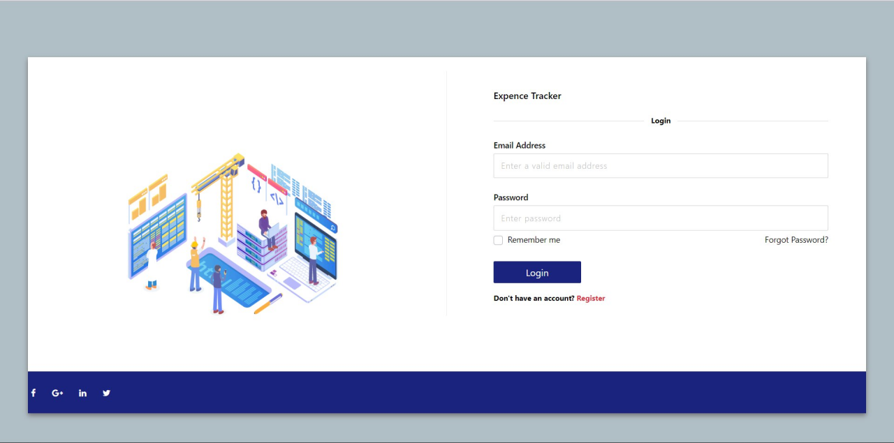

***7.2 Feature***  ***2***

<html>

<head>

    <!-- Latest compiled and minified CSS -->

    <meta name="viewport" content="width=device-width, initial-scale=1">

    <script type="text/javascript" src="https://code.jquery.com/jquery-1.7.1.min.js"></script>

    <link href="https://fonts.googleapis.com/icon?family=Material+Icons" rel="stylesheet">

    <script>

        function updateDiv()

        {

            $( "#home" ).load(window.location.href + " #home" );

        }

        window.setTimeout(function () {

            $(".alert").fadeTo(500, 0).slideUp(500, function () {

                $(this).remove();

            });

        }, 4000);

        function openForm() {

            document.getElementById("myForm").style.display = "block";

        }

        function openrecord(value) {

            document.getElementById("recordform").style.display = value;

        }

        function closeForm() {

            document.getElementById("myForm").style.display = "none";

        }

        function limgraph(value) {

            document.getElementById("limgraph").style.display = value;

            document.getElementById("limform").style.display = 'none';

        }

        function limForm(value) {

            document.getElementById("limform").style.display = value;

            document.getElementById("limgraph").style.display = 'none';

        }

    </script>

    <style>

        html {

            /* FF3.6-15 */

            background: -webkit-linear-gradient(-45deg, #de437d 0%, #5b44b9 100%);

            /* Chrome10-25,Safari5.1-6 */

            /* W3C, IE10+, FF16+, Chrome26+, Opera12+, Safari7+ */

            /* IE6-9 fallback on horizontal gradient */

        }

        svg {

            margin: 0 auto;

            text-align: center;

            width: 100%;

            padding-top: 40px;

        }

        polyline {

            stroke-dasharray: 1000;

            stroke-dashoffset: 1000;

            animation: dash 3s ease-in forwards;

            animation-direction: alternate;

        }

        @keyframes dash {

            to {

                stroke-dashoffset: 0;

            }

        }

        p {

            font-size: 2rem;

            text-align: center;

            color: #efefef;

        }

        .name {

            font-size: .10rem;

            font-weight: light;

        }

    </style>

    <link href="https://cdn.jsdelivr.net/npm/bootstrap@5.2.2/dist/css/bootstrap.min.css" rel="stylesheet">

    <link href="static/style.css" rel="stylesheet">

    <!-- Latest compiled JavaScript -->

    <script src="https://cdn.jsdelivr.net/npm/bootstrap@5.2.2/dist/js/bootstrap.bundle.min.js"></script>

    <ul class="nav bg-dark nav-pills sticky-top">

        <li class="nav-item">

                <li class="nav-item">

                    <a class="btn nav-link bg-dark {% if active=='home' %}active{%endif %}" data-bs-toggle="pill"

                        href="#home" id="log">Home</a>

                </li>

                <li class="nav-item">

                    <a class="btn nav-link bg-dark {% if active=='profile' %}active{%endif %}" data-bs-toggle="pill"

                        href="#profile" id="log">Profile</a>

                </li>

                <li><a class="btn nav-link btn-outline-dark" data-bs-toggle="pill"

                        href="#logout">Logout</a></li>

        </li>

    </ul>

</head>

<body class="bg-black">

    <div class="{% if msg =='error' %}alert alert-warning{% else %}visually-hidden {% endif %}">

        <strong>Warning!</strong> {{session.msg}} <strong>failed.</strong>

    </div>

    <div class="{% if msg =='success' %}alert alert-success{% else %}visually-hidden {% endif %}" role="alert">

        <strong>success!</strong> {{session.msg}} <strong>completed.</strong>

    </div>

    <!-- Tab panes -->

        <div class="tab-pane container active" id="home">

            {% if session.username != None %}

            <div class="container-fluid">

                <div class="row pt-5">

                    <div class="col-4">

                        <div class="card" style="width:400px">

                            <div class="card-body">

                                <h4 class="card-title">Balance</h4>

                                <p class="card-text text-{{text}}">{{session.balance}}.00</p>

                                <a href="#" onclick="openForm()" class="btn btn-primary">Change Balance</a>

                                <div class="form-popup" id="myForm" style="display:none;">

                                    <form action="/changebalance" method="POST">

                                        <div class="mb-3 mt-3">

                                            <input type="text" class="form-control" id="balance"

                                                placeholder="Enter new balance" name="balance">

                                        </div>

                                        <button type="submit" class="btn btn-light btn-outline-success"><i

                                                class="material-icons">done</i></button>

                                        <button type="button" class="btn btn-light btn-outline-danger"

                                            onclick="closeForm()"><i class="material-icons">highlight_off</i></button>

                                    </form>

                                </div>

                            </div>

                        </div>

                    </div>

                    <div class="col-4">

                        <div class="card" style="width:400px">

                            <div class="card-body">

                                <h4 class="card-title">Expence Limit</h4>

                                <p class="card-text text-{{limtext}}">{{session.expence}}.00/{{session.limit}}.00</p>

                                <a href="#" onclick="limForm('block')" class="btn btn-primary">update limit</a>

                                <a href="#" onclick="limgraph('block')" class="btn btn-primary">show remaining

                                    percent</a>

                                <div id="limgraph" style="display:none;">

                                    <div id="pie" class="pie animate text-dark">{{session.percent}}%</div>

                                    <script>

                                        document.getElementById("pie").style =

                                            "--p:{{session.limit}};--c:{{session.limitcolor}}";

                                    </script>

                                    <a href="#" onclick="limgraph('none')" class="btn btn-danger"><i

                                            class="material-icons">highlight_off</i></a>

                                </div>

                                <div class="form-popup" id="limform" style="display:none;">

                                    <form action="/changelimit" method="POST">

                                        <div class="mb-3 mt-3">

                                            <input type="text" class="form-control" id="limit"

                                                placeholder="Enter new limit" name="limit">

                                        </div>

                                        <button type="submit" class="btn btn-light btn-outline-success"><i

                                                class="material-icons">done</i></button>

                                        <button type="button" class="btn btn-light btn-outline-danger"

                                            onclick="limForm('none')"><i

                                                class="material-icons">highlight_off</i></button>

                                    </form>

                                </div>

                            </div>

                        </div>

                    </div>

                    <div class="col-4">

                        <div class="card" style="width:400px">

                            <div class="card-body">

                                <h4 class="card-title">Income</h4>

                                <p class="card-text text-{{inctxt}}">{{session.income}}</p>

                                <a href="#" class="btn btn-primary">History</a>

                            </div>

                        </div>

                    </div>

                </div>

                <div class="row pt-5">

                    <div class="col-12">

                        <button class="btn btn-primary" style="width:100%;" onclick="openrecord('block')">Add Record</button>

                        <div class="form-popup" id="recordform" style="display:none;">

                            <!-- record forms-->

                        </div>

                    </div>

                </div>

                <!-- <div class="row pt-5">

                    <div class="col-4">

                        <div class="card bg-dark" style="width:400px">

                            <div class="card-body">

                                <h4 class="card-title">-</h4>

                                <div class="pie animate card-text text-light" style="--p:90;--c:lightgreen">90%</div>

                                <a href="#" class="btn btn-primary">History</a>

                            </div>

                        </div>

                    </div>

                    <div class="col-4">

                        <div class="card bg-dark" style="width:400px;">

                            <div class="card-body">

                                <h4 class="card-title">-</h4>

                                <div class="pie animate text-light" style="--p:90;--c:lightgreen">90%</div>

                                <a href="#" class="btn btn-primary">History</a>

                            </div>

                        </div>

                    </div>

                    <div class="col-4">

                        <div class="card bg-dark" style="width:400px">

                            <div class="card-body">

                                <h4 class="card-title">-</h4>

                                <div class="pie animate text-light" style="--p:90;--c:lightgreen">90%</div>

                                <a href="#" class="btn btn-primary">History</a>

                            </div>

                        </div>

                    </div> -->

                    <div class="row pt-5">

                        <div class="col-4">

                            <div class="card bg-light" style="width:400px">

                                <div class="card-body col-9">

                                    <h4 class="card-title">Expence</h4>

                                    {% if session.recordsExpence %}

                                    <table id="myTable" class="table table-striped">

                                        <thead>

                                            <tr>

                                                <th>S.no</th>

                                                <th>TO</th>

                                                <th>AMOUNT</th>

                                                <th>CATEGORY</th>

                                                <th>Date</th>

                                            </tr>

                                        </thead>

                                        <tbody>

                                            {% for n in session.recordsExpence %}

                                            <tr>

                                                <td>{{n[0]}}</td>

                                                <td>{{n[1]}}</td>

                                                <td>{{n[2]}}</td>

                                                <td>{{n[3]}}</td>

                                                <td>{{n[4]}}</td>

                                            </tr>

                                            {%endfor%}

                                        </tbody>

                                    </table>

                                    <a href="#" class="btn btn-primary">History</a>

                                    {%else%}

                                    <p class="card-text text-danger">No records found</p>

                                    <button type="button" class="btn btn-primary btn-rounded btn-icon"><i

                                            class="material-icons">add</i></button>

                                    {% endif %}

                                </div>

                            </div>

                        </div>

                        <div class="col-4">

                            <div class="card bg-light" style="width:400px">

                                <div class="card-body col-9">

                                    <h4 class="card-title">Transfer</h4>

                                    {% if session.recordsTransfer %}

                                    <table id="myTable" class="table table-striped">

                                        <thead>

                                            <tr>

                                                <th>S.no</th>

                                                <th>TO</th>

                                                <th>AMOUNT</th>

                                                <th>CATEGORY</th>

                                                <th>Date</th>

                                            </tr>

                                        </thead>

                                        <tbody>

                                            {% for n in session.recordsTransfer %}

                                            <tr>

                                                <td>{{n[0]}}</td>

                                                <td>{{n[1]}}</td>

                                                <td>{{n[2]}}</td>

                                                <td>{{n[3]}}</td>

                                                <td>{{n[4]}}</td>

                                            </tr>

                                            {%endfor%}

                                        </tbody>

                                    </table>

                                    <a href="#" class="btn btn-primary">History</a>

                                    {%else%}

                                    <p class="card-text text-danger">No records found</p>

                                    <button type="button" class="btn btn-primary btn-rounded btn-icon"><i class="material-icons">add</i></button>

                                    {% endif %}

                                </div>

                            </div>

                        </div>

                        <div class="col-4">

                            <div class="card bg-light" style="width:400px">

                                <div class="card-body col-9">

                                    <h4 class="card-title">Income</h4>

                                    {% if session.recordsIncome %}

                                    <table id="myTable" class="table table-striped">

                                        <thead>

                                            <tr>

                                                <th>S.no</th>

                                                <th>TO</th>

                                                <th>AMOUNT</th>

                                                <th>CATEGORY</th>

                                                <th>Date</th>

                                            </tr>

                                        </thead>

                                        <tbody>

                                            {% for n in session.recordsIncome %}

                                            <tr>

                                                <td>{{n[0]}}</td>

                                                <td>{{n[1]}}</td>

                                                <td>{{n[2]}}</td>

                                                <td>{{n[3]}}</td>

                                                <td>{{n[4]}}</td>

                                            </tr>

                                            {%endfor%}

                                        </tbody>

                                    </table>

                                    <a href="#" class="btn btn-primary">History</a>

                                    {%else%}

                                    <p class="card-text text-danger">No records found</p>

                                    <button type="button" class="btn btn-primary btn-rounded btn-icon"><i class="material-icons">add</i></button>

                                    {% endif %}

                                </div>

                            </div>

                        </div>

                    </div>

                </div>

            </div>

            {% else %}

            <p>You are not logged in. Login <a href="/redirect"><strong>here</strong><a></p>

            {% endif %}

        </div>

        <div class="tab-pane container {% if active=='logout' %}active{%else%}fade{%endif %}" id="logout">

            <div class="alert alert-success">

                <strong>Success!</strong> Logout <strong>completed.</strong>

            </div>

            <p>Login <a href="/redirect"><strong>here</strong><a></p>

        </div>

    </div>

    </div>

</body>

</html>

***7.3 Database***

Create table login (

loginid integer not null GENERATED ALWAYS AS IDENTITY (START WITH 1 INCREMENT BY 1),

email varchar(225) not null,

name varchar(225) not null,

Username varchar(225) not null,

password varchar(225) not null,

phonenumber bigint not null,

PRIMARY KEY(email),

UNIQUE(username)

);

Create table limits(

limitid integer not null GENERATED ALWAYS AS IDENTITY (START WITH 1 INCREMENT BY 1),

email varchar(225) not null,

limit integer not null default 0,

expence integer not null,

limit_from date not null default CURRENT DATE,

limit_to date not null,

primary key (limitid),

foreign key (email) references login(email)

);

Create table category(

categoryid integer not null GENERATED ALWAYS AS IDENTITY (START WITH 1 INCREMENT BY 1),

email varchar(225) not null,

name varchar(225) not null,

PRIMARY KEY(categoryid),

UNIQUE(name),

foreign key (email) references login(email)

);

Create table records(

expenceid integer not null GENERATED ALWAYS AS IDENTITY (START WITH 1 INCREMENT BY 1),

email varchar(225) not null,

amount integer not null,

category integer not null,

type varchar(225) not null,

PRIMARY KEY(expenceid),

foreign key(email) references login(email),

foreign key(category) references category(categoryid),

check (type in ('Expence','Income','Transfer'))

);

alter table expence add column to_acc varchar(225) not null default 'None';

alter table records add column updation_date date not null default CURRENT DATE;

drop table category;

insert into login(email,name,username,password,phonenumber) values('1912019@nec.edu.in','Prasanna Kumar A', '1912019', '1912019', 9791521808);

alter table login add column transfer integer default 0;

drop table expence;

alter table login drop column balance;

insert into category(email,name) values('1912019@nec.edu.in','Food');

insert into records(email,to_acc,amount,category,type) values('1912019@nec.edu.in','rep',200,1,'Expence');

CALL SYSPROC.ADMIN_CMD('REORG TABLE category');

CALL SYSPROC.ADMIN_CMD('REORG TABLE login');

CALL SYSPROC.ADMIN_CMD('REORG TABLE records');

CALL SYSPROC.ADMIN_CMD('REORG TABLE limits');

select * from login;

Select * from records;

**8 Testing**

***8.1 Test Cases***

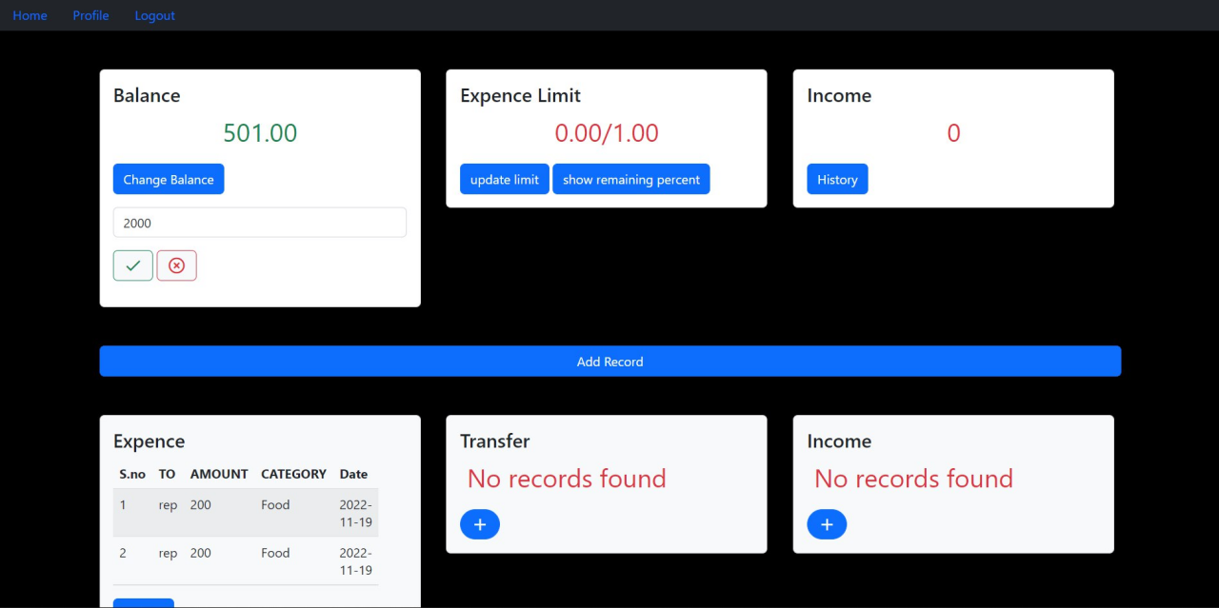

**9 Results**

***9.1.PERFORMANCE METRICS***

1. RESULTS

The performance of a recommendation algorithm is evaluated by using some specific metrics that indicate the accuracy of the system. The type of metricused depends on the type of filteringtechnique. Root Mean Square Error (RMSE), Receiver Operating Characteristics (ROC), Area Under Cover (AUC), Precision, Recall and F1 score is generally used to evaluate the performance or accuracy of the recommendation algorithms.

***Root-mean square error (RMSE)***. RMSE is widely used in evaluating and comparing the performance of a recommendation system model compared to other models.A lower RMSE value indicateshigher performance by the recommendation model. RMSE, as mentionedby [[61]](https://encyclopedia.pub/entry/13081#ref_61), can be as represented as follows:



|  |  |
| --- | --- |
|  |  |
|  |  |

where, *Np* is the total number of predictions, *pui* is the predicted rating that a user *u*will selectan item *i*and *rui*is the real rating.

***Precision***. Precision can be defined as the fraction of correct recommendations or predictions (known as True Positive) to the total number of recommendations provided, which can be as represented as follows:

It is also defined as the ratio of the number of relevant recommended items to the numberof recommended items expressed as percentages.

***Recall***. Recall can be defined as the fraction of correct recommendations or predictions (known as True Positive) to the total number of correct relevant recommendations provided,which can be as represented as follows:



It is also defined as the ratio of the number of relevant recommended items to the totalnumber of relevant items expressed as percentages.

***F1 Score***. F1 score is an indicator of the accuracy of the model and ranges from 0 to 1, wherea value close to 1 representshigher recommendation or prediction

accuracy. It represents precision and recall as a singlemetric and can be as represented as follows:



***Coverage***. Coverageis  used to measure the percentage of items whichare recommended by the algorithm amongall of the items.

***Accuracy***. Accuracycan be defined as the ratio of the numberof total correctrecommendations        to        the         total                                    recommendations            provided



**10 ADVANTAGES & DISADVANTAGES**

**Advantages**

1. This system helps a person to reduce their expenses.
2. Easy to use.
3. You’ll have better insight into your spending habits.
4. It provides a better overviewand comprehensive analysis.
5. Saving and Investment.

**Disadvantages**

1. May get inaccurate results if data is not inserted in correct manner.
2. User have to entry every record manually.
3. Person who is handlingsystem must have some technicalknowledge

**11 CONCLUSION**

The new system has overcome most of the limitations of the existing system and works according to the design specification given. The project what we have developed is work more efficient than the other income and expense tracker. The project successfully avoids the manual calculation for avoiding calculating the income and expense per month. The modules are developed with efficient and also in an attractive manner. The developed systems dispense the problem and meet the needs of by providingreliable and comprehensive information. All the requirements projectedby the user have been met by the system. The newly developed system consumes less processing time and all the details are updated and processed immediately. Since the screen provides online help messages and is very userfriendly, any user will get familiarized with its usage. Module s are designed to be highly flexible so that any failure requirements can be easily added to the modules without facing many problems. The best organizations have a way of tracking and handling these reimbursements. This ideal practice guarantees that the expenses tracked are accurately and in a timely manner. From a company perspective, timely settlements of these expenses when tracked well will certainly boost your employees' morale

* Quickly DetermineHow Profitable Business Is

* Effective expensetracking and reporting to avoid conflict

**12 FUTURE SCOPE**

Expense management software solutions have come a long way from being mere reporting tools. They have evolved because of the advances in the spheres of automation and artificial intelligence. [Expense management software](https://kissflow.com/finance/expense-management/top-expense-management-software/)that employ the latest technology are an absolute must-have for every organization, irrespective of the size or industry.

Companies have been gradually adopting expense management software in a bid to mitigate the losses associated with expense frauds and wasted time. The speed of adoption and change, however, needs to keep pace with emerging trends in the industry.